Day 3 Activity 2

- Input: Interpretive Comprehension
(a) email
- Students in pairs first read an email written by Yi’an about a trip to Riyue Tan, a lake in the middle of Taiwan. Yi’an is an American student, currently studying in Taiwan, sent this email to his friend who live in USA.
- Ask students to underline the transportations used to get to Riyue Tan.

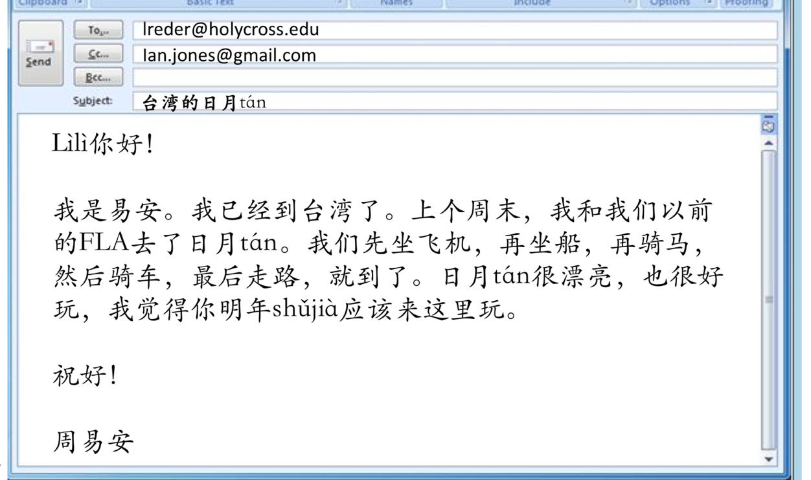

- Indicate the means of transportation Yi’an Zhou took in order when going to Riyue Tan.

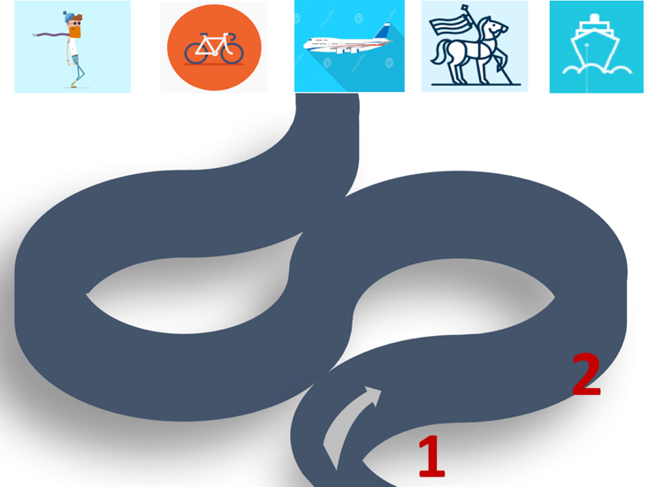

B. Output: Presentational Writing
- email
- Students in pairs first read another email by Yi’an (day3 act2 worksheet Task B). He sent the email to his Chinese teacher and asked several questions related to transportation.
- Circle the questions Yi’an asked.
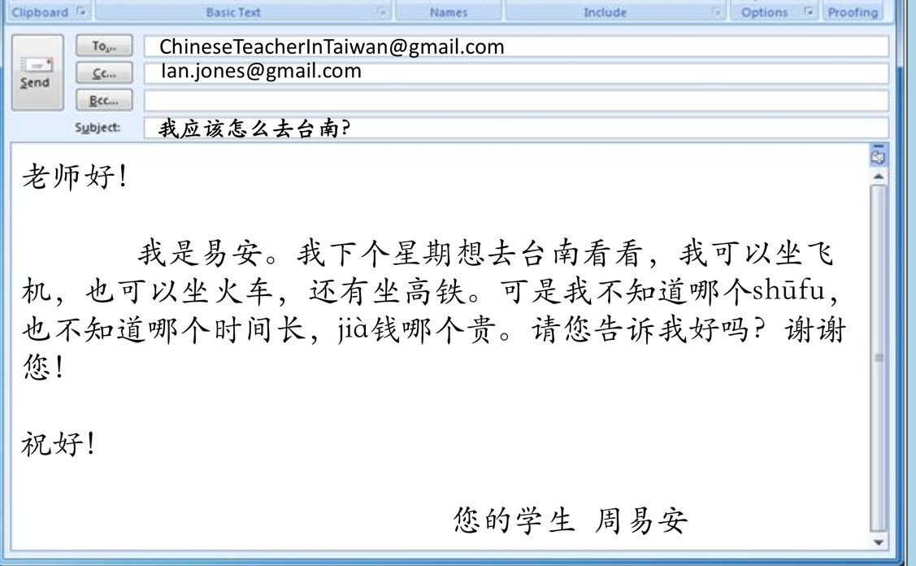
- Chart
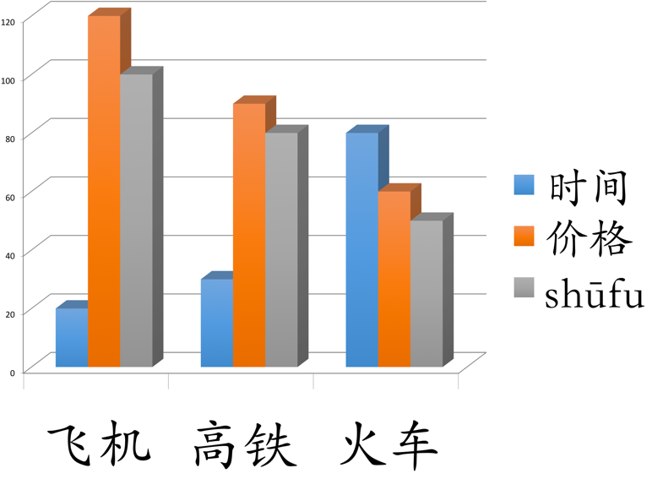
- Write an email to respond to Yi’an’s questions based on the above chart.

